***Round fluffy cat***

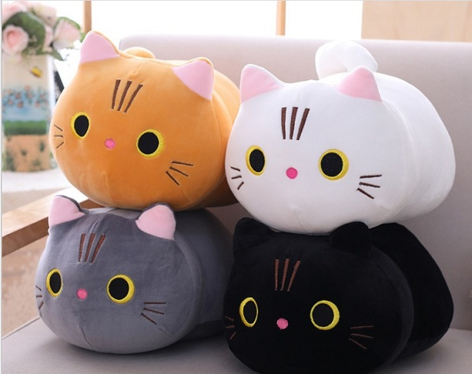

*Round cotton cat is made of smooth cotton material, safe to use.  
  
The product has many colors for you to choose: white, yellow, gray and black. You can note the color you want to choose when ordering. Shop will contact you to finalize the order before sending.  
  
Size length 35cm.  
  
Round fluffy cats are suitable as gifts for babies, girlfriends gifts, birthday gifts or children's Tet gifts, ...*